MGT602 - Business Decision Analytics
Assessment 2 - Decision Style Analysis Reflective report

Student Name & ID Number:
Kequn HE A00076016
Carreon Carrasco, Ignacio A00045758
Patel, Dhaval Ashwinbhai A00043166
Ganta Vijay Chakravarthy A00034820
Campos Delgado, Wesner Jair A00042361

Learning Facilitator: Heinz Herrmann

Trimester 1 (2022)

Cover Sheet

Executive Summary
The research report has been commissioned with the purpose of analysing the shortage of chip during COVID and its solutions to overcome this problem. In order to evaluate the problem and its sources, variety of decision making tools has been used to analyse the problem. Moreover, rational approach of decision making has been adopted to engage the group in decision with effective results. The research has analysed the causes of chip shortage through relational model to effectively analyse the data and suggest strategic solutions. The Chip shortage has been occurred due during the COVID due to reduced production, lockdowns in the industries and increased demand of chip by the electronics firms.
Firms are facing challenges in their production due to shortage of chip. Based on the analysis, rational approach of decision making has helped to analyse the alternative solutions for the problem. From the identified alternatives, two of the alternatives are selected to provide a quick solution and could face future difficulties. These alternatives are investment in tech firms and in-house supplies manufacturing to meet the rising demand and reduced supply. To reach a satisfactory and competitive decision, rational approach along with brain storming in group work has help in the process. In addition, individual analysis has also been performed to have different view-points in the final decision. At the end, final decision has been made considering the analysis of the problem which can help in improving chip supply.

Table of Contents
Cover Sheet 2
Executive Summary 3
Introduction 5
Background of the study 6
Relevant internal and external data sources that the organization may have used in the decision-making process 8
Analysis and influence of individuals and group dynamics impact on the decision-making 9
Analysis of the decision-making process 10
Visual interpretation and presentation of relevant data / trends/ patterns 16
Conclusion 20
References 21
Appendix A 23
Appendix B 28
Appendiz C 30

Introduction
This assessment has been created by focusing on the semiconductor shortage that was introduced by the COVID 19 pandemic. In preparing this assessment, we apply our individual decision-making techniques and interpret a range of data analyses. During the pandemic, multiple organizations that manufacture electronic devices associated with increased online sales that led to an increase in the demand for multiple IT equipment, including computers, mobile phones, tab, laptops, gaming systems, and so on. For this, the demand for semiconductors increased on a large scale. Unfortunately, due to the limited supply chain, the individual organization failed to manufacture demanded products, and shortages rose in the entire microchip manufacturer industry. We have submitted an in-depth decision-making process that Intel has used to deal with this semiconductor shortage. Here we have identified individual person or persons that play the key role within Intel to make the decision and try to evaluate how individual data analysis technics influence individuals and groups of the organization. In completing this assessment, we have used an analytical theory of business and key approaches to identifying the impact of individual decisions of this organization on society. Additionally, we used our learning from different modules that include time management, business decision-analytic approach, collaborative information processing, and a few more.
This business decision style analysis reflective report starts with the background on how the uncertain introduction of COVID 19 pandemic steadily introduced global semiconductor shortage and how multiple microchip manufacturing organizations responded to this global shortage. Next, we have included the internal and external data analysis process that Intel used during this pandemic. Further, we have tried to identify an individual person or persons that make a decision in this company and analysis how their decision impact on individuals and working groups. Finally, we have also analyzed the decision-making process considering all theories and concepts discussed in Modules 1, 2, 3, and 4.

Background of the study
Electronics and automobile industries have been adversely impacted by the uncertain introduction of the COVID 19 pandemic. In terms of major impact, every electronic organization faces a semiconductor shortage. Due to the pandemic and the introduction of the global lockdown situation, there introduced a sudden drop in the manufacturing process. However, the demand for microchips increased steadily because of the rapid shifting of people’s working and interaction processes to digital. During the pandemic, multiple organizations that manufacture electronic devices associated with increased online sales that led to an increase in the demand for multiple IT equipment, including computers, mobile phones, tab, laptops, gaming systems, and so on. For this, the demand for silicon (a core element of microchips) increased on a large scale. For the increased demand, foundry organizations started reducing their manufacturing time to fulfill the demand. As a result, at the end of 2020, the time from order to delivery reduced to 1 to 2 months for silicon and other semiconductor materials required for manufacturing microchips which generally takes approx. 3 to 4 months before the pandemic. During Spring 2021, this order to delivery time was reduced to 15 weeks. This unexpected reduction of order to delivery time introduces a prolonged and continuing squeeze on the worldwide semiconductor supply chain.
In response to this huge demand and the inadequate capacity of multiple semiconductor fabrication plants, few organizations will make considerable investments in 2020. However, multiple industries also made a significant investment to construct new facilities for fabrication plants. For example, the Taiwan Semiconductor Manufacturing Company has partnered with Sony for building 22 and 28-nanometre chips in Japan. According to sources, they will start producing microchips in late 2024. On the other side, Intel also invested 20 billion USD in Arizona to build new foundries.
The semiconductor shortage due to the pandemic significantly grabs the attention of policymakers. According to sources, an executive order (EO no: 14017) was signed by President Biden on 24th February 2021, to review the semiconductor’s supply chain, pharmaceuticals, and critical materials related to the development of microchips. There introduce considerable changes in government policies and national interests to coordinate the raised vulnerability in semiconductor’s supply chain. All these new policies significantly helped to reinforce semiconductor manufacturing. Through these new policies and national interest, different fabrication plants successfully deploy inventory reserves, develop resilience planning and eliminate redundancy processes in manufacturing (Barbara, 2021). Proper flow of data and effective analysis approaches also helped them to develop a better BCP (Business Continuity Plan) to make themselves future proof against similarly increased demand.

In this business decision analytic report, we have chosen the Intel Corporation. Here we have tried to evaluate how this company makes effective decisions during the global semiconductor shortage situation and how its individual decision impacts its operational process and influences individuals without disturbing the business dynamics.

Relevant internal and external data sources that the organization may have used in the decision-making process
Internal decision-making in Intel
For more than five decades, Intel has successfully designed and manufactured its own semiconductors so that its product provides a unique user experience. With the introduction of the COVID 19 pandemic, Intel was associated with some added challenges. The global semiconductor shortage was already introduced major issues; in addition, with this Intel faced multiple challenges for its complex product development process. In terms of internal decision-making, Intel significantly changed its product manufacturing architecture according to the supply chain. During the pandemic situation, Intel significantly used advanced analytical strategies to develop innovative capabilities to reorganize its product development system so that it could properly utilize the available supply (Informs.org, 2022). According to sources, Intel has used effective supply chain planning through which they tried to minimize the production cost so that their product become available at a lower price (due to the semiconductor shortage, prices of individual electronic devices was increased almost two to three times more) and the organization still hold the most reliable position for the consumers. With device physics simulation and genetic algorithm, they evaluate more optimized product design alternatives, which allows them to expand the fabrication process to fulfill the consumer demand as much as possible.
External decision making of Intel
To stay valued, Intel focused on proper time management. From an interview with Patrick P. Gelsinger, it has been found that Intel is effectively working with the supply chain of the entire microchip manufacturing industry. According to current reports, Intel did a great job in terms of maintaining a supply of CPUs, GPUs, Wi-Fi devices, and so on. This becomes possible for them by focusing on and effectively handling the consumer-focused decision-making process (Jamshed, 2022). They have done the necessary research to identify the high demanding products and used almost all the available semiconductor supplies to develop that demanding segment. Along with these, Intel also made collaboration to enhance their product performance and use AI to make the customer experience better. All these key decision-making aspects allow Intel to stay in the leading and dominating position still now.

Analysis and influence of individuals and group dynamics impact on the decision-making
Individuals always have interaction with individuals from the internal or external of the group and the group itself, this is why sociology emphasizes on the power of the group. When a group of people work together, the decision they made is not merely credited to the specific individual. Groups are dynamic and powerful as they have the power to influence the individual and communities. Groups sometimes eliminate or completely abolish the counter-productive behaviors of the individuals (Jex & Britt, 2014, p.6). This can be seen as a positive influence of the group effect. On the other hand, hardworking team members in a low productive team may find themselves offsets due to the pressure brought to them, as a result, they tend to work with less effort or just quit from the group. The concept of “Group dynamics” is about any changes occurring in any part of the group, and the action and response of the individuals resulting from the changes in the group structure (Gençer, 2019, p. 223). Group dynamics have an important role in the quality and creativity of the decision. Groups with hierarchy such as the army will have the best efficiency in decision making, although there may be lack of enough creativity. If the decision requires creativity the group needs to include the equality in the status of individuals and the well management, so that individuals can make the best contribution to the decision (Adams, 2015). The power is not only related to the individual’s position in the group structure but also the individual’s attributes and personalities such as dominance, attractiveness and charisma. The formal or informal differences in the power will lead to depression, dissatisfaction and self-conflict that will eventually impede the effectiveness in group decision. Groups with rational decision style tend to make the rational decision, as per the hypothesis that combination of the group members with rational model is a key factors in establishing a rational team at the early stage of the team development (Zhu et al., 2020, p. 1281)
The group 14 of the MGT602 Business Decision Analytics is a group assignment team of 5 members. The group is full with diversity as the team members came from different countries with different languages and cultural backgrounds. The majority of the team members have a rational model for the decision making style, as a brief summary of the team members can be found in the following Appendix C.
As for the Identification of the key person or persons making the decision, it can be found on Appendix B.

Analysis of the decision-making process
To understand the current problem in the supply chain of microchip manufacturing for electronic devices, it is important to be clear about the current landscape and what its status was prior to the Covid 19 pandemic.
The shortage problem
The microchip industry is currently facing a global shortage of chips. This crisis has been caused by the outbreak of COVID-19, which has disrupted production at microchip factories around the world.
The effects of the COVID-19 pandemic have been far-reaching, affecting not just microchip manufacturers, but also suppliers and distributors. As a result, consumers are starting to see shortages of electronic products in all segments, from smartphones to laptops.
There are several factors that have contributed to the current microchip shortage. First, many factories have been forced to close due to the spread of COVID-19. Second, even those factories that remain open are operating at reduced capacity. And finally, there has been a significant increase in demand for microchips, as consumers switch to electronic products that are less affected by the pandemic.
Bearing in mind that there are three main companies in the manufacture of these electronic elements such as Samsung, TSM and Intel (table 1), they have not managed to reduce the shortages in their supply chains and have used different strategies in order to mitigate the impact for the following months.

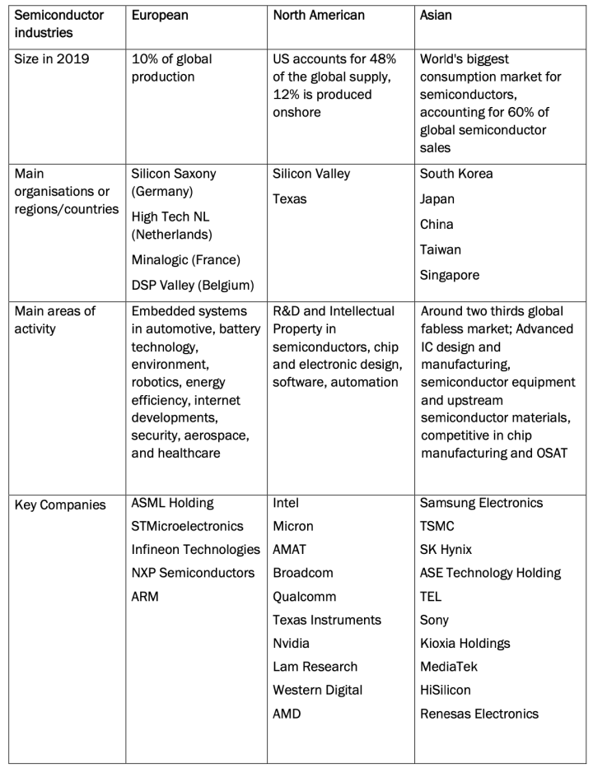Table 1: European, North American, and Asian Semiconductor Industries
From: https://csconnected.com/wp-content/uploads/2022/02/Huggins-Johnston-Munday-Xu-The-Future-of-Europes-Semiconductor-Industry.pdf

Once we have a clearer context of the impact and those involved, the following decision models are derived that in one way, or another will help to contribute to a prompt and effective solution, Image 1 Relational Model.
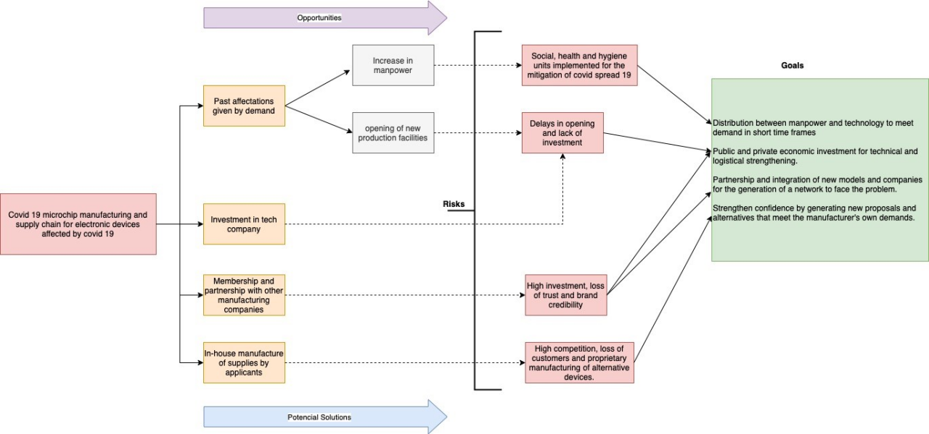 Image 1. Relational Model to Microship shortage Electronic Devices .Own Elaboration (Jair Campos B.A)
An intuitive process would not be very recommendable for decision making, given the uncertainty provided by the end of the pandemic in the coming months, and given the short time it has taken for the development of an effective vaccine, another point is the fact that more than one solution is required and each of them in a way that faces the situation and is novel to the current demand given the massive and growing consumption in electronic devices, figure 1.

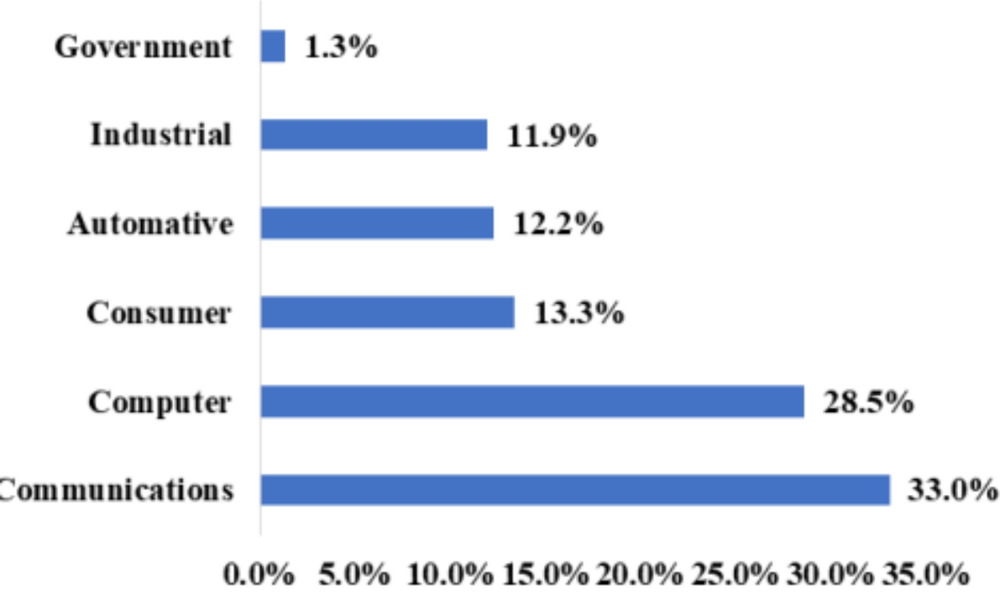
Deciding which of the solutions may be more effective than the other may in some ways affect ethical and moral issues that need to be addressed and balanced in the decision, for example, an increase in working hours to reduce the problem may in some ways be ethically undefined, because of the times and breaks of the workforce and morally affect their availability.
A Relational model (Image 1) could be more successful in decision making to solve the problem with the supply chain of microchips for electronic devices.
First, we have identified the problems: Pandemic covid 19 and production shortages due to strong demand.
Second, we must limit and parameterise achievable goals, in terms of the solution to the problem, bearing in mind that there is a bias in the information and a level of uncertainty that can vary these scopes in a short time.
Third, there are alternative solutions that would give relief in the short and medium term, among them the following:

  - · Increasing the production plant (Opening of new manufacturing sites), the establishment should be given geographically and strategically to cover the demand in the countries most affected with these supplies, time and costs. However, cases such as the supply chains created by Bosch in Reutlingen (Cucignatto, et al., 2022), take a long time to set up and would not provide a quick solution to the current situation but would anticipate future demand.
  - · Implementation of new automated machinery to shorten manufacturing times and be available 7/24 h, thereby alleviating the problem of long working hours for workers. The ciao requires a strong investment and government support for its renovation and technification (Huggins, et al., 2022)
  - · Incorporation of other manufacturing companies, integration, costs and time should be evaluated (Huggins, et al., 2022).
  - · Letting demanding companies create their own supply chain to supply their own needs, as in the case of Apple with the creation of its own microchips. Focus production on higher demand electronic devices that require this supply chain, mitigating risk.
Taking into account the previous scenario and the different alternatives proposed and evaluated according to a rational context, as a working group, alternatives were taken into account and under discussion that would provide a quick solution and that in one way or another these alternatives would face future difficulties, so that not only one of them was selected, but two of them were taken into account, table 2.

Alternative | Weight | Vote Team Member 1 | Vote Team Member 2 | Vote Team Member 3 | Vote Team Member 4 | Vote Team Member 5 | Total
Past affectations given by demand | 2 |  |  |  | 2 |  | 2
Investment in tech company | 2 | 2 |  |  |  | 2 | 4
Membership and partnership with other manufacturing companies | 3 |  |  |  |  |  | 0
In-house manufacture of supplies by applicants | 4 |  | 4 | 4 |  |  | 8
Table 2. Making Decision – Alternatives Solution Team Group
Own Elaboration

Visual interpretation and presentation of relevant data / trends/ patterns
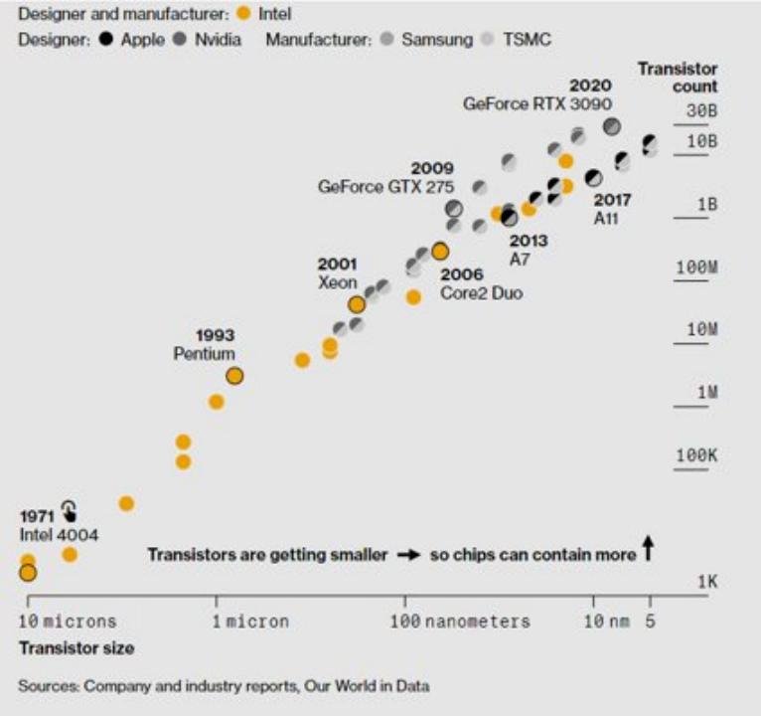
https://www.bloomberg.com/graphics/2021-chip-production-why-hard-to-make-semiconductors/
Number of transistors per chip
The following graph shows the number of transistors in a chip. It can be seen how over the years the number has been increasing because technology has allowed the creation of smaller transistors which can be more easily stored in more powerful chips and small.
This is a clear example of how the various electronic products that we use every day have become more complex, adapting technologies related to the Internet of Things, which makes their production and operation more difficult to handle.

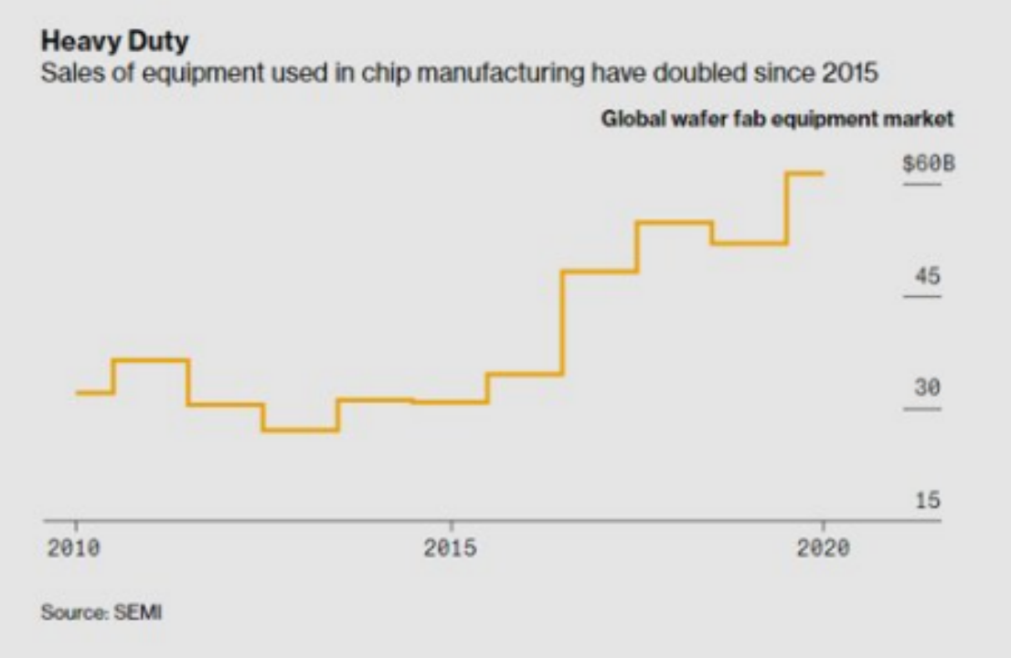https://www.bloomberg.com/graphics/2021-chip-production-why-hard-to-make-semiconductors/
Sales of equipment
The companies dedicated to the manufacture of chips have had to adapt to the demand generated by the increase in the sale of electronic products. The numbers show that the sale of equipment related to the manufacture of chips has reached record levels that have exceeded the figures from previous years.

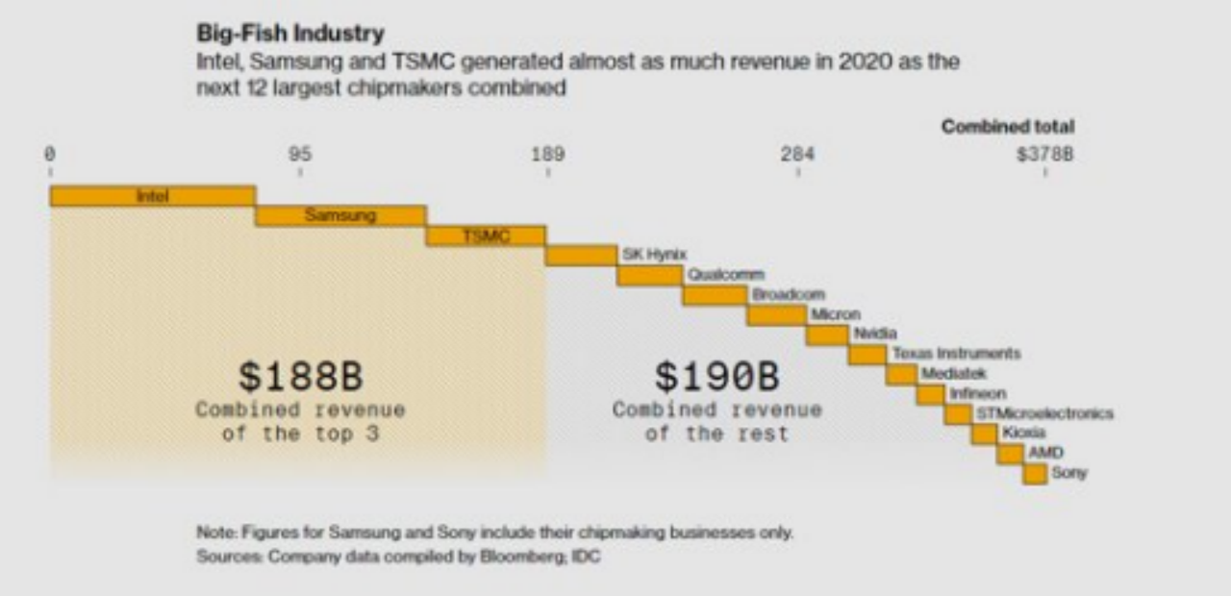https://www.bloomberg.com/graphics/2021-chip-production-why-hard-to-make-semiconductors/

The chip manufacturing market is dominated primarily by 3 players, who control nearly half of the industry-wide profits. The investments required in the sector are considerable due to the type of expertise (facilities, technology, equipment and trained personnel) that is required, so not just any company is capable of entering the sector.
Some companies related to the world of electronics have divisions in charge of manufacturing chips, which increases their value in the supply chain, acquiring a competitive advantage over other players in the market.
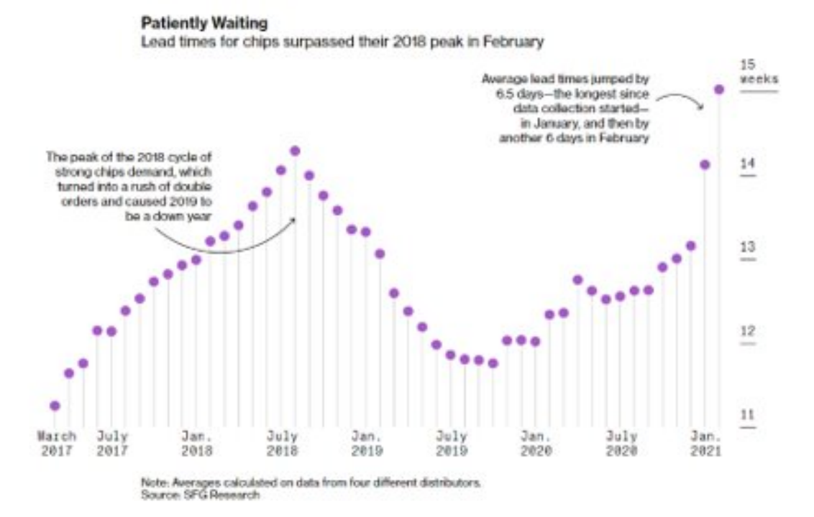
https://www.bloomberg.com/graphics/2021-semiconductors-chips-shortage/
Waiting times
Since the start of the health contingency due to covid 19, the demand for electronic products has increased significantly, which in turn has generated an increase in the number of chips required by the industry. Companies of all sizes encounter logistical and production problems due to waiting times that, as can be seen in the graph, sometimes reach 15 weeks per order.

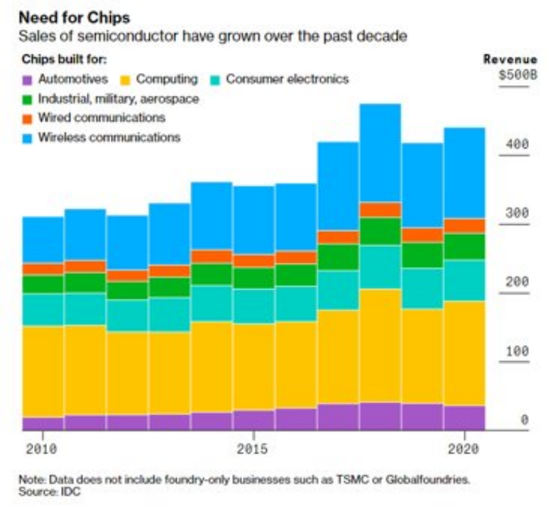
https://www.bloomberg.com/graphics/2021-semiconductors-chips-shortage/
Chips needed in each industry
Chips have become indispensable in our daily lives. Practically all electronic products that we use every day have some kind of chip that makes them work optimally. The number of chips it contains will depend on the product, so as it becomes more complex, the more chips it will require for its operation.
An example of this is vehicles. It can be clearly seen how over time their characteristics have increased considerably, all thanks to technological functions that were not previously available but now provide a better user experience.

Conclusion
As can be seen in the report, chips have become a fundamental part of our daily lives, so problems associated with the supply chain have a significant impact on the supply and availability of different products that we use daily.
In order to offer solutions regarding the problems previously indicated, the team used the relational method which tries to maximize the given value with consistent and logical alternatives.
Among the solutions found, we can conclude that the team members gave more weight to two in particular, the first focused on increasing investment in production and in the plant itself to better meet demand, and the second, the support and advice to electronic companies for the development of chips within their own facilities.​

References

Adams, A. (2015, October 16). How group dynamics affect decisions. https://news.stanford.edu/features/2015/decisions/group-dynamics.html
Barbara Chang (2021): Pandemic Supply Chain Issues Highlight Dependence on Semiconductors. Available at: https://www.air-worldwide.com/blog/posts/2021/12/pandemic-supply-chain-issues-semiconductors/ [Retrieved on 7th April 2022]
Bakay, A., Huang, J., & Huang, Y. (2014). Group decision-making processes and group decision quality: moderation of mutual interest. International Journal Of Management And Decision Making, 13(4), 335. https://doi.org/10.1504/ijmdm.2014.065347
Baker, E. (2013). Relational Model Bases: A Technical Approach to Real-time Business Intelligence and Decision Making. Communications Of The Association For Information Systems, 33. https://doi.org/10.17705/1cais.03323
Cucignatto, G., Gaddi, M., & Garbellini, N. (2022). Covid-19 and Industrial Restructuring: What Future for Transnational Value Chains. ETUI Research Paper-Working Paper. DOI: https://papers.ssrn.com/sol3/papers.cfm?abstract_id=4042633
Acceded from 04/04/2022.
Du, S. (2022, March). Research on Countermeasures to Economic Challenges Faced by Enterprises in the Environment of Semiconductor Industry. In 2022 7th International Conference on Financial Innovation and Economic Development (ICFIED 2022) (pp. 667-672). Atlantis Press. DOI: https://www.atlantis-press.com/proceedings/icfied-22/125971925. Acceded from 04/04/2022.
Gençer, H. (2019) Group Dynamics and Behaviour. Universal Journal of Educational Research, 7(1), 223-229. https://doi.org/10.13189/ujer.2019.070128
Huggins, R., Johnston, A., Munday, M., & Xu, C. (2022). The Future of Europe’s Semiconductor Industry: Innovation, Clusters and Deep Tech. ISO 690. DOI: https://csconnected.com/wp-content/uploads/2022/02/Huggins-Johnston-Munday-Xu-The-Future-of-Europes-Semiconductor-Industry.pdf Acceded from 03/04/2022.
Informs.org (2022): Intel uses O.R. in Corporate Decision-making, Realizing $25 Billion in Benefits. Available at: https://www.informs.org/Impact/O.R.-Analytics-Success-Stories/Intel-uses-O.R.-in-Corporate-Decision-making-Realizing-25-Billion-in-Benefits [Retrieved on 7th April 2022]
Jex, S., & Britt, T. (2014). Organizational Psychology - A Scientist-Practitioner Approach

Jamshed Avari (2022): How Intel is Handling the Global Chip Shortage, Arc GPUs for PC Builders, and More: Interview with Gregory Bryant. Available at: https://gadgets360.com/laptops/features/intel-global-chip-shortage-pandemic-evo-platform-arc-gpu-graphics-interview-ces-2022-gregory-bryant-2713525 [Retrieved on 7th April 2022]
Kugler, T., Kausel, E., & Kocher, M. (2012). Are Groups More Rational than Individuals? A Review of Interactive Decision Making in Groups. SSRN Electronic Journal. https://doi.org/10.2139/ssrn.1990201
Zhu, X., Wolfson, M., Dalal, D., & Mathieu, J. (2020). Team Decision Making: The Dynamic Effects of Team Decision Style Composition and Performance via Decision Strategy. Journal of Management, 47(5), 1281-1304. https://doi.org/10.1177/0149206320916232

Appendix A
​​Peer evaluation and comments to team member

 | Team member name | Rating –(1 to 5) | Comments to team member
1 | Kequn HE A00076016 | 5 | initiated and invited all members to the Whatsapp group to enable members to have an updated communication, created Google Doc so members can work simultaneously, take notes for group meetings on every stage of the team project.
2 | Carreon Carrasco, Ignacio  A00045758 | 5 | Took proactively participate in the team work, always providing positive advice and up-to-date information of the group assignment.
3 | Patel, Dhaval Ashwinbhai  A00043166 | 5 | Work hard for the assignment, a really good contributor.
4 | Ganta, Vijay Chakrvarthy  A00034820 | 5 | Always giving postive responses in the group, always working with initiative.
5 | Campos Delgado, Wesner Jair A00042361 | 5 | Worked hard on the assignment and finalized own part on a timely manner, and communicated well with the team.
 | Team member name | Rating –(1 to 5) | Comments to team member
1 | Carreon Carrasco, Ignacio  A00045758 | 5 | I Tried to be proactive during the communication that I had with my colleagues trying to propose the topics to work on and invite others to participate to complement our ideas.  I shared some articles and sources where we could inform ourselves about the topic discussed
2 | Kequn HE A00076016 | 5 | Very active during the conversations, he helped us with the issues related to the establishment of the Whatsapp group and the documentation related to work. He made the right decisions and was accessible with his colleagues.
3 | Patel, Dhaval Ashwinbhai  A00043166 | 5 | He had initiative when working with certain specific aspects of the assessment. His attitude was excellent and he helped us clarify some doubts related to the recordings and the class in general.
4 | Ganta, Vijay Chakrvarthy  A00034820 | 5 | He contributed in an optimal way for the decision making of the solutions and helped in the planning of the proposed models.
5 | Campos Delgado, Wesner Jair | 5 | I finish all the work on time and correctly. In a proactive way, he indicated to us everything that was already there, in the same way, he helped a great deal in the decision-making process during the work.
 | Team member name | Rating –(1 to 5) | Comments to team member
1 | Patel, Dhaval Ashwinbhai  A00043166 | 5 | Worked with different innovative ideas and finally finished our report.
2 | Kequn HE A00076016 | 5 | Great Work with group
3 | Carreon Carrasco, Ignacio  A00045758 | 5 | Great communication skills with groups
4 | Ganta, Vijay Chakrvarthy  A00034820 | 4 | Good efforts with great ideas
5 | Campos Delgado, Wesner Jair | 4 | Good feedback and support in our report
 | Team member name | Rating –(1 to 5) | Comments to team member
1 | Ganta, Vijay Chakravarthy  A00034820 | 5 out of 5 | i worked really hard for this assessment to finish in time by using decision making models
2 | Kequn HE A00076016 | 5 out of 5 | he took initiative as a team leader and managed to work done in time
3 | Carreon Carrasco, Ignacio  A00045758 | 5 out of 5 | he is also cooperative and helped me few particular things in this assessment
4 | Patel, Dhaval Ashwinbhai  A00043166 | 5 out of 5 | we had a chat and shared a lot of decision making models in different scenarios not only for this assessment but also other topics as well
5 | Campos Delgado, Wesner Jair | 5 out of 5 | he clarifies a lot of things to me regarding this assessment and helped me a lot
 | Team member name | Rating –(1 to 5) | Comments to team member
1 | Campos Delgado, Wesner Jair | 5 out of 5 | I have worked from an analytical and rational point of view, contributing and supporting different points of view and decision-making in the group.
2 | Kequn HE A00076016 | 5 of 5 | There has been a very good contribution, ensuring communication with the use of technological tools for this purpose.
3 | Carreon Carrasco, Ignacio  A00045758 | 5 of 5 | Their knowledge about the issue raised has awakened a particular interest in the in-depth analysis for the different solution alternatives, there was encouragement from that point.
4 | Patel, Dhaval Ashwinbhai  A00043166 | 4 of 5 | He has been attentive to the comments, his contributions have been presented on time
5 | Ganta, Vijay Chakrvarthy  A00034820 | 5 of 5 | His contributions contributed to the understanding of the problems of the case study, he has collaborated effectively with the working group in a disinterested manner.

Personal Reflection - Wesner Campos

The process of decision analysis is a fundamental point for the analysis of every adverse situation that requires a prompt solution and that is in accordance with social and ethical dynamics. In many occasions we are biased to the comments without a deep analysis of the situations, we wait for the common creation of a specific or global group, however this route in the decision making has achieved a particular interest in the comparative and analytical, with this I have more bases that support my decisions and it has been of great help this work together with the members of the team when you see to analyse each point of view. With this case study, my inclination has been towards a relational model, given its particularities and, as I mentioned before, a detailed analysis of the information consulted, which further reinforces the choice of one or several alternatives to the situation presented in the report.

Personal Reflection - Vijay Chakravarthy Ganta

Group work has been a great experience to learn about effective decision making. We worked as a team and collaborated to resolve the identified problem of chip shortage. Decision making process and learning about the decision making tools is a great experience for future professional life and helped me to develop my decision making skills. I have further learned about decision making process to make some suggestions for the identified problem and we as a team made our efforts to avoid group think in the decision making. I have learned to work to work in team which comprises of members from diverse cultural backgrounds, nature and personal values.
This key learning will be a great skill for me in my future life. Biases are common in making decisions and in this group work I have learned and made all the efforts to avoid the biases impact our decision and final selection of alternatives. This has been a great experience to analyze literature and information from the journal articles and websites and analyze the relevant information which has developed my research skills (Li et al., 2017). Moreover, I have learnt about approaches to decision making and its application in different contexts and situations. We used a rational approach to decision making which has been of great use in such crisis situations.

Appendix B
Records of Meeting

 | Who | What | How | When
Week 1 | Kequn HE | Initiate the group | Created Whatsapp group and invited all team members into the group | 16/03/2022
Week 1 | Ignacio, Dhaval, Carreon, Kequn HE | Discussed the availability of time for group meeting | Defining the specific time/date for meeting is difficult for an online class without members being physically attended, the group all agreed through voting to have meetings on Whatsapp so everything can be organized with messages that members can be always kept posted without missing the important information regarding the project.  Meeting notes:  Ignacio, Dhaval are available for mornings,  Campos is ok with mornings in the weekends  Kequn HE is available on Wednesday and weekends. | 19/03/2022
Week 2 | All members | Disscussed requirements of the assignment and allocation of individual work | Ignacio - Visual interpretation and presentation of relevant data / trends/ patterns  Conclusion  Dhaval - introduction,  Background to the case,  Collection of relevant internal and external data sources that the organization may have used in the decision-making process  Kequn HE - Identification of the key person or persons making the decision  Analysis and influence of individuals and group dynamics impact on the decisionmaking  Part C records of weekly group meetings  Ganta - Executive summary  Analysis of the decision-making process  Campos - Analysis of the decision-making process | 27/03/2022
Week 3 | All members | Proposal for the topic of the assignment and the solution to tackle down the problem resulted from the assigned industry | Topic: Microchip/semiconductor shortage due to Covid (Team agreed on the proposal from Ignacio)  Specific industry: Car industry (Campos, ignacio voted) or  phones or  electronic devices (Ganta, Petel, Kequn HE voted)  Solution: accumulate chip reserves  reduce components in each products  focus on other products with less chips  buy wholesale  Find other suppliers  delay delivery dates. (Ignacio proposed)  Create new facilities  Government investments  Company technification(modernisation and automation)  Strategic alliances to meet demand in strategic global locations (Campos proposed)  Raising funds in R&D and developing self-supplied chips production cabability (Kequn HE proposed) | 10/04/2022

Appendix C
Brief summary of the team

Our project team comprised of five members with diversified language and culture background. Table below listed a summary of each team member.

Name & Student ID | Summary of Team Member
Kequn HE A00076016 | As the project coordinator, Kequn HE also works as a project coordinator in a Import & Export company. Kequn was originally from China, can speak Chinese and English, with Bachelor degree of International Economies and Business in China and Master of Professional Accounting in Australia. With 4 years of international business work experience, Kequn has worked with clients with different cultural backgrounds all over the world, and gained qualified business analytics and customer relationship management skills which can be also applied to the undergoing project. He is believed to have a rational style in the decision-making process.
Carreon Carrasco, Ignacio  A00045758 | Originally from Mexico city,Ignacio has developed a large part of his professional career in the financial sector,specifically in the areas of banking,insurance and pension funds.With Bachelor of Business studies and Diplomas oriented to entrepreneurship, Ignacio can bring an enterprise vision to the team and support issues related to Project and Capital Management.
Patel, Dhaval Ashwinbhai  A00043166 | My self Dhaval Patel From India (Gujrat). I have done my Bachelor of Mechanical In India and i also worked on many projects in mechanical engineering with team leader. Now I am doing MBA (Advanced).
Ganta, Vijay Chakrvarthy  A00034820 | myself vijay,i am from india and i can speak english and telugu.i completed my bachelors in mechanical engineering in india and i used to work as project lead team member in automotive service center and dealt the clients with different communities and regions with my different decision making process according to situation,mostly rational style.
Campos Delgado, Wesner Jair | Currently I work for a company as a business analyst and part of my background has been as a leader of the data warehouse and big data in a telecommunications company, thanks to this and the absorption of information has defined my analytical criteria in decision making, more rational and logical level.

